Formulas and calculations done as part of the test
The measurement of high voltage using sphere gaps involves determining the breakdown voltage or the voltage at which electrical breakdown occurs in the gap between two spheres. The Paschen's Law is commonly used to estimate the breakdown voltage in sphere gaps.

Paschen's Law relates the breakdown voltage (V) to the product of the gas pressure (P) and the gap distance (d) using the following equation:

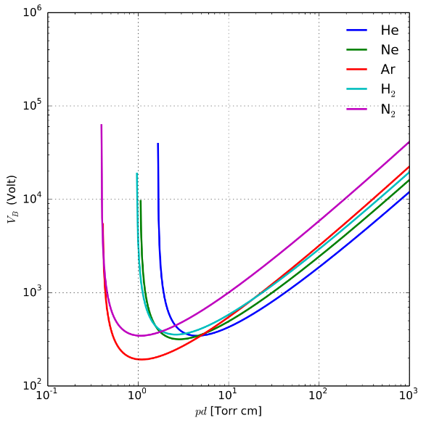
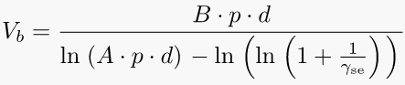

where:
- $V_{b}$ is the breakdown voltage
- A is the saturation ionization in the gas at a particular E/p (electric field/pressure), and B is related to the excitation and ionization energies.
- A and B are determined experimentally and found to be roughly constant over a restricted range of E/p for any given gas
- p is the gas pressure
Paschen curves obtained for helium, neon, argon, hydrogen and nitrogen, using the expression for the breakdown voltage as a function of the parameters A, B that interpolate the first Townsend coefficient.
- d is the gap distance
- $γ_{se}$ is the secondary-electron-emission coefficient (the number of secondary electrons produced per incident positive ion)

To perform the calculation, we need to know the gas pressure, the gap distance, and the specific value of the constant A and B for the given gas and electrode configuration. The constant A and B can be determined experimentally or obtained from published sources for commonly used gases.

Note: The actual breakdown voltage in practice may deviate from the values predicted by Paschen's Law due to various factors such as surface conditions, electrode shape, and gas impurities. Experimental verification and calibration are often necessary for accurate measurements.

Which standards are followed during the tests?

During the measurement of high voltage with sphere gaps, there are several standards that are commonly followed to ensure accurate and reliable results. Some of the key standards of CEPEL that are often referenced in this field include:

ABNT NBR IEC 60060-1: This Brazilian standard, which is based on the international IEC 60060-1 standard, provides guidelines for high-voltage test techniques. It covers definitions, general requirements, test procedures, and measurement methods. CEPEL may refer to this standard for guidance.

IEC 60060-1: The international standard published by the International Electrotechnical Commission (IEC) offers guidance on high-voltage test techniques, including sphere gaps. It provides comprehensive information on the definitions, general requirements, test procedures, and measurement methods for high-voltage testing.

IEEE Std 4: Developed by the Institute of Electrical and Electronics Engineers (IEEE), IEEE Std 4 focuses on techniques for high-voltage testing. It provides information on test voltages, test circuits, and test procedures, which could be relevant to CEPEL's practices.

CIGRE TB 496: The guidance provided in CIGRE Technical Brochure 496, developed by the International Council on Large Electric Systems (CIGRE), on the measurement of very fast transient voltages with sphere gaps may be considered by CEPEL in specific testing scenarios.

These are some standards that are commonly followed in the field of high-voltage testing. However, for the precise standards and guidelines utilized by CEPEL in their tests, it is recommended to consult their specific publications, technical reports, or reach out to them directly for the most accurate and up-to-date information.

Reference: https://en.wikipedia.org/wiki/Paschen%27s_law

